EXP 11-20

11. PRINT ALL FACTOR OF NUMBER code
#include<iostream>
using namespace std;
int main()
{
int n;
cin>>n;
for(int i=1;i<=n;i++)
if(n%i==0)
cout<<i<<" ";
}
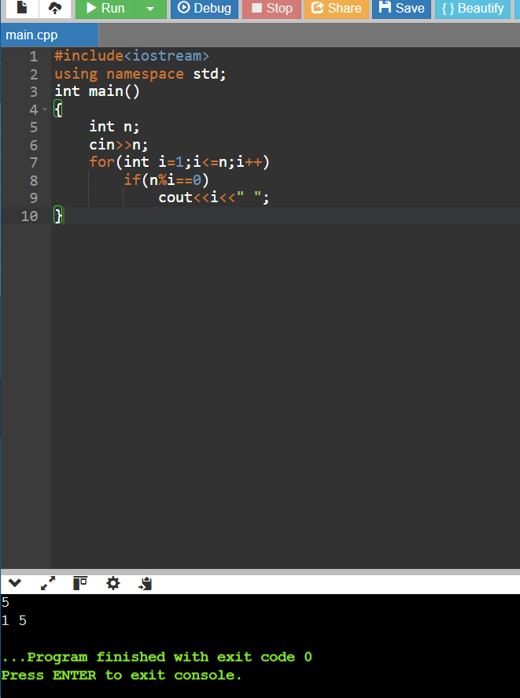
12.PYRAMID PATTERN code
#include<iostream>
using namespace std;
int main()
{
int n;
cin>>n;
for(int i=1;i<=n;i++)
{
for(int j=1;j<=i;j++)
cout<<"*";
cout<<endl;
}
}

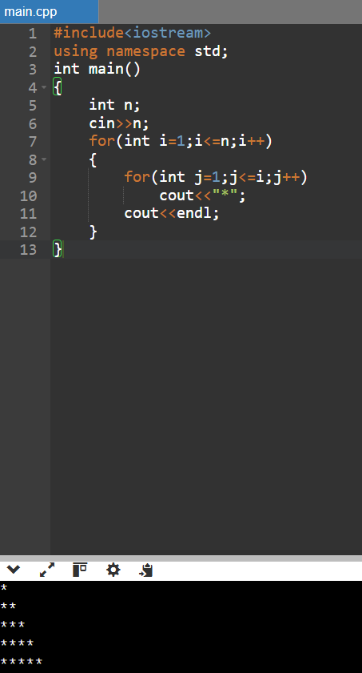
13. Find the power of a number CODE
#include<iostream>
using namespace std;
int main()
{
int a,b,p=1;
cin>>a>>b;
for(int i=1;i<=b;i++)
p*=a;
cout<<p;
}
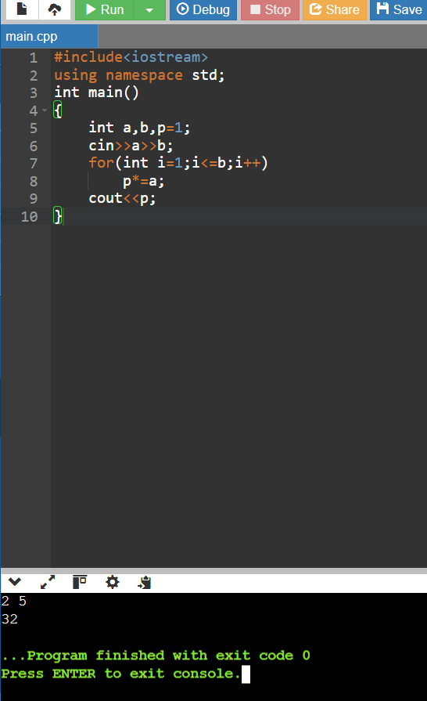
14. Inverted pyramid pattern code
#include<iostream>
using namespace std;
int main()
{
int n;
cin>>n;
for(int i=n;i>=1;i--)
{
for(int j=1;j<=i;j++)
cout<<"*";
cout<<endl;
}
}
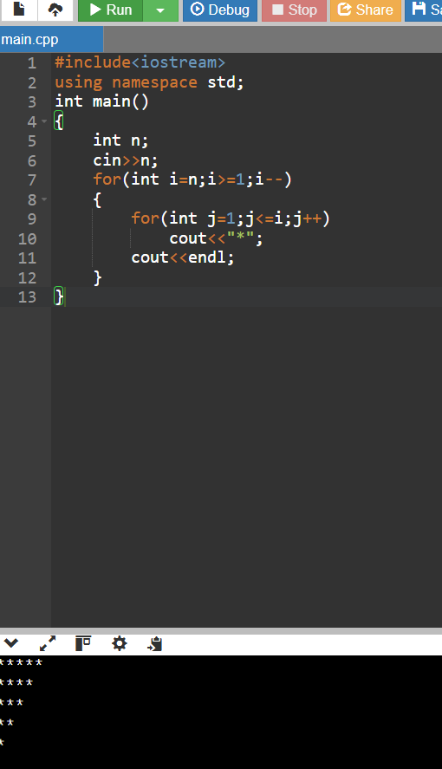
15. Find the sum of positive and negative numbers from a list code
#include<iostream>
using namespace std;
int main()
{
int n,x,p=0,ne=0;
cin>>n;
for(int i=1;i<=n;i++)
{
cin>>x;
if(x>0) p+=x;
else ne+=x;
}
cout<<"Positive="<<p<<endl;
cout<<"Negative="<<ne;
}
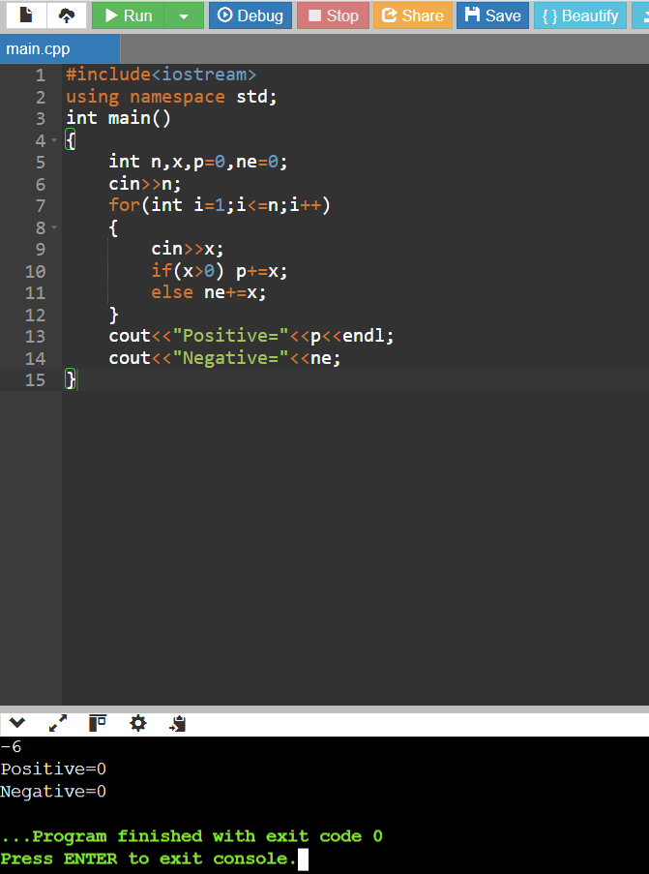
16. Print all prime numbers between two given numbers code
#include<iostream>
using namespace std;
int main()
{
int a,b,f;
cin>>a>>b;
for(int i=a;i<=b;i++)
{
f=1;
for(int j=2;j<i;j++)
if(i%j==0) f=0;
if(f&&i>1) cout<<i<<" ";
}
}
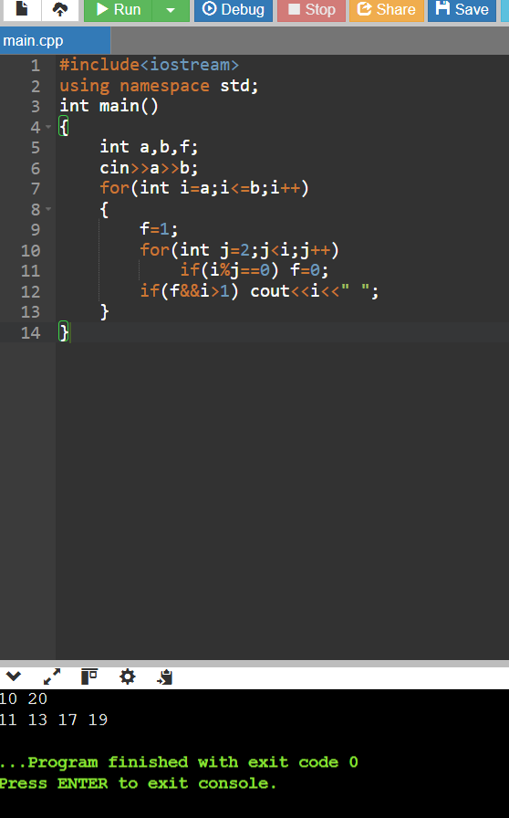
17. Generate a multiplication table code
#include<iostream>
using namespace std;
int main()
{
int n;
cin>>n;
for(int i=1;i<=10;i++)
cout<<n<<" x "<<i<<" = "<<n*i<<endl;
}
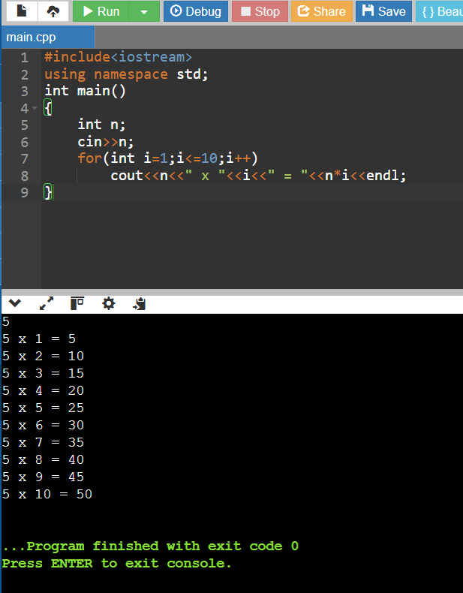
18. Check whether a number is an automorphic number code
#include<iostream>
using namespace std;
int main()
{
int n,s,d=1;
cin>>n;
s=n*n;
int t=n;
while(t){d*=10;t/=10;}
if(s%d==n) cout<<"Automorphic";
else cout<<"Not Automorphic";
}

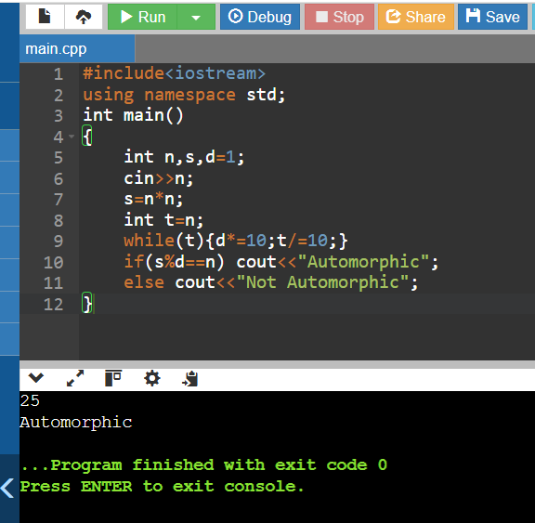
19.Diamond pattern code
#include<iostream>
using namespace std;
int main()
{
int n=3;
for(int i=1;i<=n;i++){
for(int j=1;j<=n-i;j++) cout<<" ";
for(int j=1;j<=2*i-1;j++) cout<<"*";
cout<<endl;
}
for(int i=n-1;i>=1;i--){
for(int j=1;j<=n-i;j++) cout<<" ";
for(int j=1;j<=2*i-1;j++) cout<<"*";
cout<<endl;
}
}
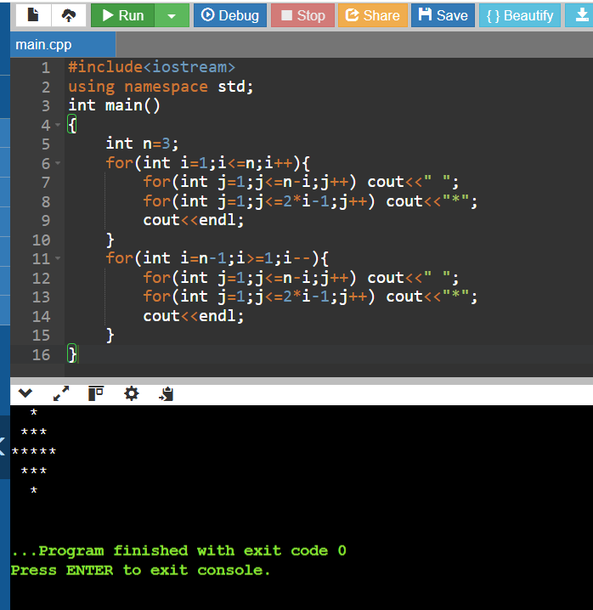
20. Convert hexadecimal to decimal and decimal to hexadecimal code
#include<iostream>
#include<iomanip>
using namespace std;
int main()
{
int n;
cin>>n;
cout<<hex<<n;
}
